**© 2015 – Foxes Team**

<http://process.ws>

**Abstract**

This document describes in detail the requirement process  
which will use to define the Requirement Plan.

**Process for**

**Requirement Management Phase**

**Foxes Project**

**Table of Contents**

1. Introduction 2

1.1. Purpose 2

1.2. Intended Audiences 2

2. Process Objectives 2

3. Requirement Process 3

4. Process Roles and Responsibilities 3

5. Process Description 4

5.1. Requirement Elicitation and Analysis 4

5.2. Requirement Specification 6

5.3. Requirement Validation 6

Revision 8

# Introduction

## Purpose

The purpose of this document is to define the requirements processes and procedures to be used by the Foxes Team in Capstone Project.

## Intended Audiences

|  |  |
| --- | --- |
| Audience | Reference Purpose |
| Customer | Review and approve their requirements. |
| Mentor | Reviewing to help Foxes team improve the quality of Requirement phase. |
| Foxes Team Members | All document |

Table - Intended Audiences

# Process Objectives

Process of Requirement Phase will:

* Steps to elicit & analyze the Requirement from customer, generate a new document named: Requirement Process.
* In order to develop and manage requirements from customer with consistency.
* The process will define how to elicitation and analyze the requirement, how to gathering the requirements and manage them effectively.

# Requirement Process

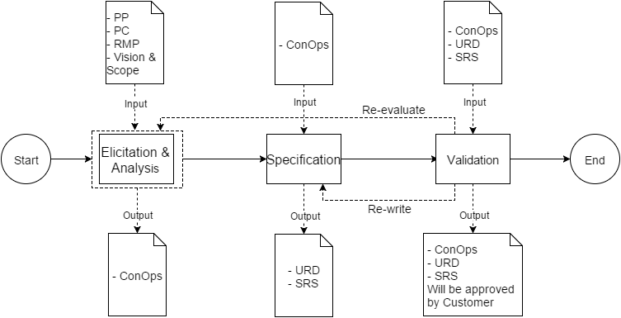

Figure 1 - Requirement Management Process

Document in this sub-process:

* PP: Project Plan
* PC: Project Charter
* RMP: Requirement Management Plan
* ConOps: Concept Of Operation
* URD: User Requirement Document
* SRS: Software Requirement Specification

# Process Roles and Responsibilities

|  |  |
| --- | --- |
| Roles | Responsibilities |
| Requirement Lead | * Develop a requirement plan and monitor, control team to follow it. * Ensure arrange adequate resource to collect and manage requirement. * Check and ensure quality of requirement documents from requirement engineer. * Contact directly with customer. * Validate requirement with customer. |
| Requirement Engineer | * Use techniques to gather and manage customer’s requirement. * Analyze the requirement. * Write documents for requirement. |
| Architect | * Consider whether requirement can be achieved or not in architecture aspect. * Focus on collect architectural drivers. |
| Stakeholder | Provide requirement and validate documents for Requirement Phase |

Table 2 – Roles and Responsibilities

# Process Description

## Requirement Elicitation and Analysis

|  |  |
| --- | --- |
| **Purpose** | By using methods to collect requirements to understand customers such as:   * Requirements, goals, objectives of customer * Constraint on software |
| **Required Input** | 1. Vision & Scope 2. Project Plan 3. Project Charter 4. Requirement Plan 5. Adequate resource for requirement phase: peoples, tools, training techniques, process for requirement development and management. |
| **Expected Output** | 1. Concept Of Operation |
| **Participants** | 1. Requirement Leader (RL) 2. Requirement Engineer (RE) 3. Quality Assurance (QA) 4. Technical Lead 5. Stakeholders |
| **Activities:**   1. First, we carry out elicitation from customer:  * Collect some basic data from customer by a survey that have question either multiple choices or short essays to customer. Then, Foxes Team will analyze, make a conclusion based on data get from customer. * In addition, team will make some questions for them to know about their working environment, current application, technical... * Conducting meeting with customer to listen and question to know more about current system (If yes). There are 2-3 members (Requirement Leader, Requirement Engineer, Technical Lead, QA) will attend that meeting. We will meet them directly and work with them. Some techniques will use in this meeting: * **Interview**: one asks and the other notes. Team also prepare some scenarios, when customer raise some ideas, we will use those scenarios to explore more information. * **Brainstorming**: we will let customer brainstorming to raise their ideas, which not have in some interview scenario or questions. We will discuss with them about that and write down all to analyze later. * **Prototyping** to help customer know more interface of application and website.  1. Then, basing on elicitation we carry out analyzing by use some technical:  * **5 W + 1 H** (Why, what, who, when, where and How) to analyze and define customer’s need and most of element (may be process flow, quality attribute, technical/Business constraint …) in project to priority requirement. * **Interview** to get solution from all members. * **Questionnaire**: use google doc to create survey for customer * **Brainstorming**  1. After that, implementing priority requirement based on trade-off among requirements to make decision, then develop solution for customer.   Finally, conducting verify that solution are correct and meet customer needs.(Elicitation and Analysis may be executed multiple times (loop) to get the most requirements correct)  4. We must confirm the ConOps document to get approval by customer in the meeting. **If Yes** - Customer approve this ConOps document, we will execute next step (“Specification” step). And **If No** - Customer doesn’t approve, we will re-work this step until got approval the ConOps document by customer. | |

## Requirement Specification

|  |  |
| --- | --- |
| **Purpose** | Create and complete URD and SRS documents clearly based on the ConOps document was approved and get approval from Customer to finish the Requirement phase. |
| **Required Input** | 1. Concept Of Operation (COnOps) |
| **Expected Output** | 1. User Requirement Document (URD) 2. Software Requirement Specification (SRS) |
| **Participants** | 1. Requirement Leader (RL) 2. Requirement Engineer (RE) 3. Technical Lead 4. Quality Assurance (QA) 5. Stakeholders |
| **Activities:**   1. After Requirement Analysis phase, based on the ConOps document was approved, Foxes Team will conduct URD and SRS documents. 2. The team will held a meeting with customer to present about URD and SRS documents (Mockup, list of Use Cases …). This meeting will help all stakeholders consistent with one another. Besides, it help customer clearly about features, functions when project team develop software. 3. After completing the documents, the team must confirm the URD and SRS documents to get approval by customer in the meeting. **If Yes** - Customer approved the documents, the team will move to next step (“Validation” step). And **If No** - Customer didn’t approve, the team will re-work this step until got approval the URD and SRS documents. | |

## Requirement Validation

|  |  |
| --- | --- |
| **Purpose** | By conducting validation to ensure that the requirements are necessary and sufficiently specified to meet customer’s needs before development begins and project team build product which make customer satisfaction. |
| **Required Input** | 1. Concept Of Operation (COnOps) document – be approved 2. User Requirement Document (URD) document – be approved 3. Software Requirement Specification (SRS) document – be approved |
| **Expected Output** | 1. Concept Of Operation (COnOps) document – be baselined 2. User Requirement Document (URD) document – be baselined 3. Software Requirement Specification (SRS) document – be baselined |
| **Participants** | 1. Requirement Leader (RL) 2. Requirement Engineer (RE) 3. Technical Lead 4. Quality Assurance (QA) 5. Stakeholders |
| **Activities:**   1. Establish meeting with customer and project team to present all documents, this presentation will help all stakeholders consistent with one another. 2. Simultaneously, in this meeting, the team will get approval from customer to baseline all documents of Requirement Phase. 3. If all documents are baselined by Customer, Foxes Team will finish the Requirement phase and move to next phase (“Architectual” phase). 4. If one or all of the document unacceptable to baseline, Foxes Team will:  * “Re-evaluate” with ConOps document until already to baseline. * “Re-write” with URD and SRS documents until already to baseline. * Finally, the team will held a meeting with Customer to get approval about all documents already to baseline after editing to baseline the documents and finish Requirement phase. | |

# Revision

|  |  |  |  |
| --- | --- | --- | --- |
| # | Date | Editor | Description |
| 6 | Oct 12th, 2015 | Chi Tô | * Updating process |
| 5 | Sep 6th, 2015 | Tỷ Trần | * Updating with the new template. |
| 4 | Aug 17th, 2015 | Chi Tô | * Review and update Process. * Complete document. |
| 3 | Aug 16th, 2015 | Chi Tô | * Complete document. |
| 2 | Aug 13th, 2015 | Chi Tô | * Updating Purpose and add “Activities” in description table. |
| 1 | Aug 1st, 2015 | Chi Tô | * Creating Document. * Defining Requirement Management Process. |